Question 01
Design a web page (InvoiceCalculation.htm) which Calculating employee salaries according to sales.

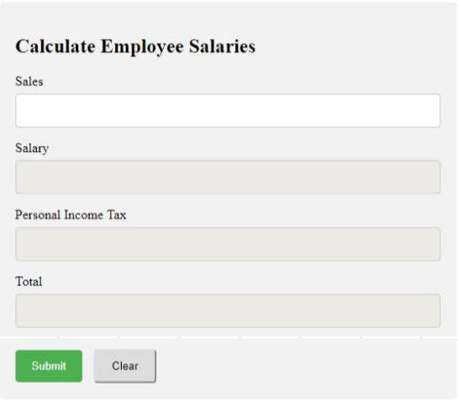
Figure 1

Salary, Personal Incom Tax, Total fields are set enable =false.
When user click submit button, perform salary calculation for employees based on this table:
Level | salary
Level 1: sales < 5000 | 5%
Level 2: sales from 5000$ to 10000$ | 10%
Level 3: sales > 10000$ | 15%

If Salary >1000 then Personal Income Tax is equal 10% of salary, otherwise is 0%.

Calulating the Total with Total = Salary – Salary * Personal Income Tax;
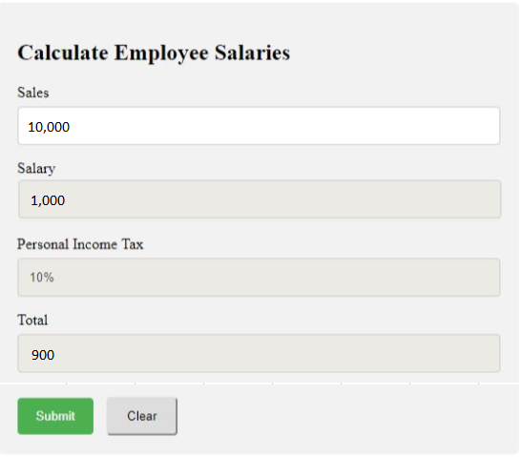
Figure 2

When user click on Clear button clear all the calculating data to user ready to input new Sales value like figure 1.
More details:
- Create user friendly interface (1 marks).
- Program data validation (1 marks):
- Calculating salary (2 marks).
- Display correct format number (ex: 1000 -> 1000(1 marks).

Question 02:

Using HTML, JavaScript to calculates student score in the classroom (file StudentsMark.htm) with the description given below:

- User prompt function declared scores of n elements, each element is the average grade and name of each student (default n = 5).
- Write a JavaScript function to enter student's score and name to the array and then print the array elements to a web page.
- Write a JavaScript function that counts the number of students have score greater than or equal to 5 and then print result to a web page.

